|  |  |
| --- | --- |
| garment inventory system |  |
|  |  |
| 2/24/2014 | Group 5 |
| Course no: CSE 308 | **Student id: 1005047,**  **1005051,**  **1005053,**  **1005056 &**  **10050 57** |

garment inventory system

Group 5

sequence diagram:

Subsystem 1: raw material storage

sequence diagram for use case 1.1(get user demand)

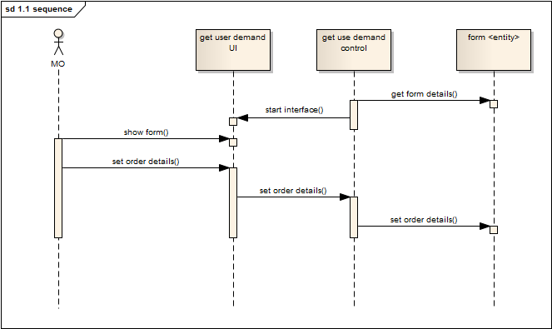

Sequence diagram for use case 1.2 (match type)

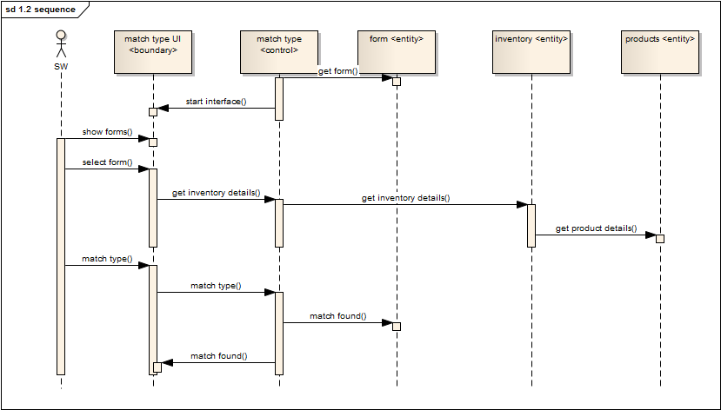

Sequence diagram for use case 1.3(match quantity)

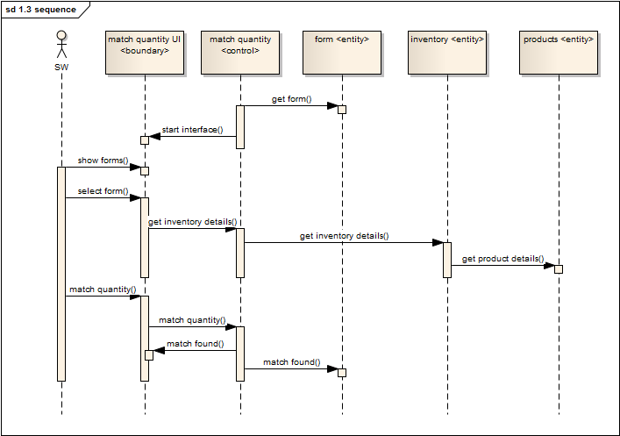

Sequence diagram for use case 1.4(confirm order)

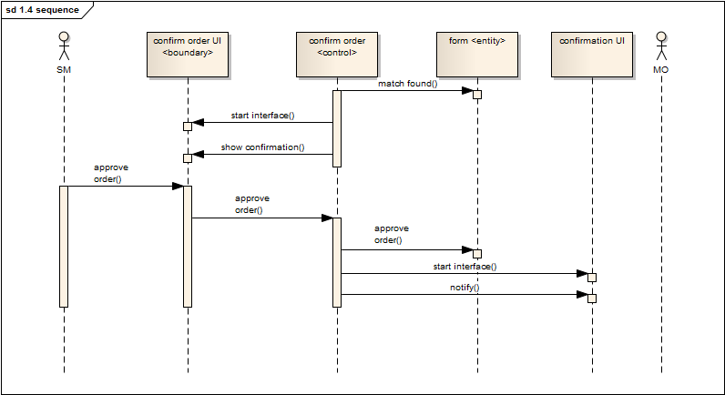

Sequence diagram for use case 1.5 (update storage balance)

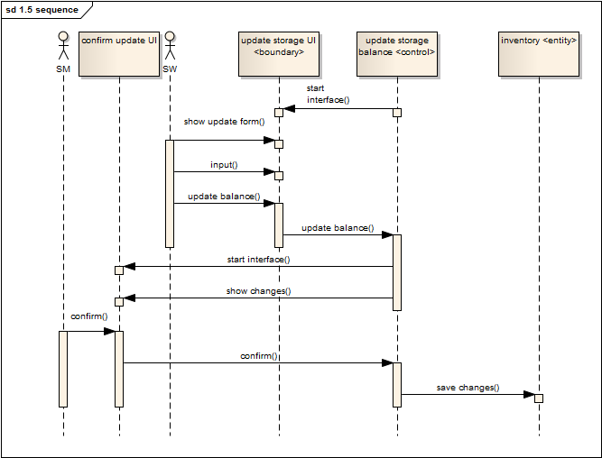

Sequence diagram for use case 1.6 (check storage balance)

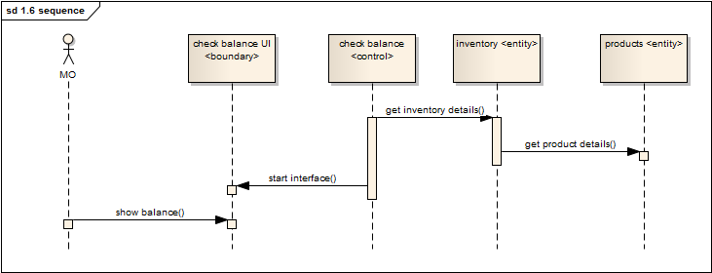

State chart diagram for entity ‘FORM’

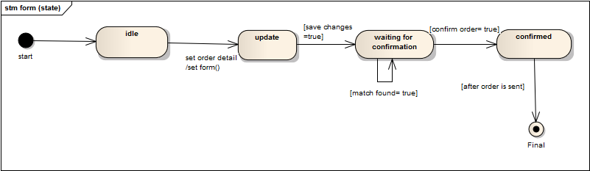

State chart diagram for entity ‘INVENTORY’

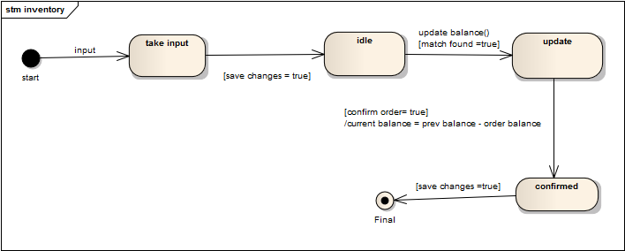

State chart diagram for entity ‘PRODUCT’



Activity diagram for RAW MATERIAL STORAGE SUBSYSTEM:

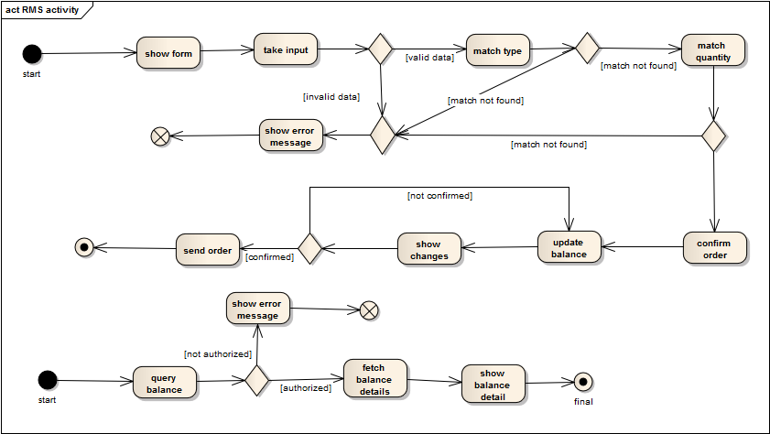

Subsystem 2: Raw material forwarding

Sequence diagram for use case 2.1 ‘view confirmation’

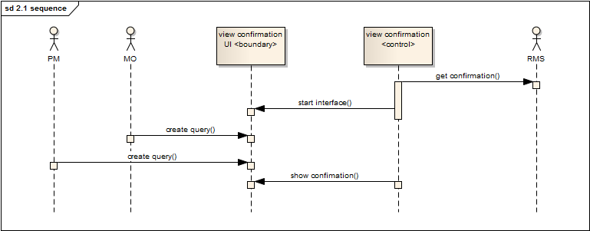

Sequence diagram for use case 2.2 ‘check forwarding status’:

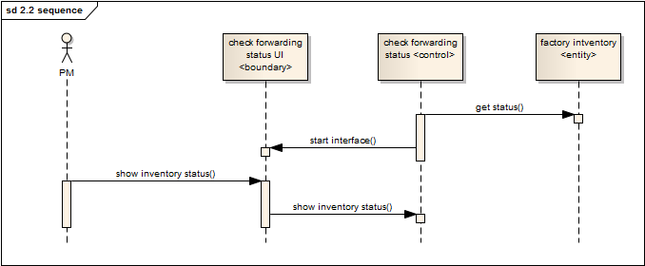

Sequence diagram for use case 2.3 ‘set floor wise target’:

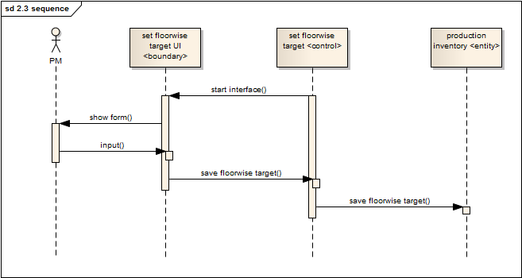

Activity diagram for “RAW MATERIAL FORWARDING” subsystem

Subsystem 3: Production Stage Tracking

Sequence diagram for use case 3.1(View Cutting Status)

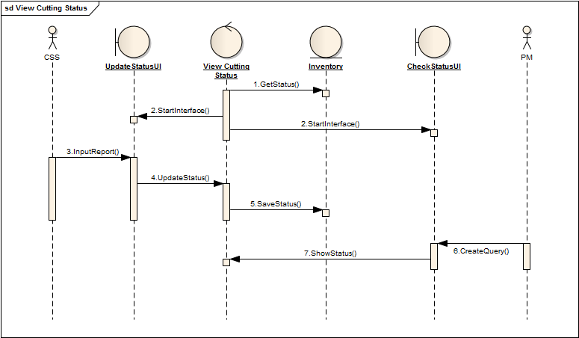

Sequence diagram for use case 3.2(View Sewing Status)

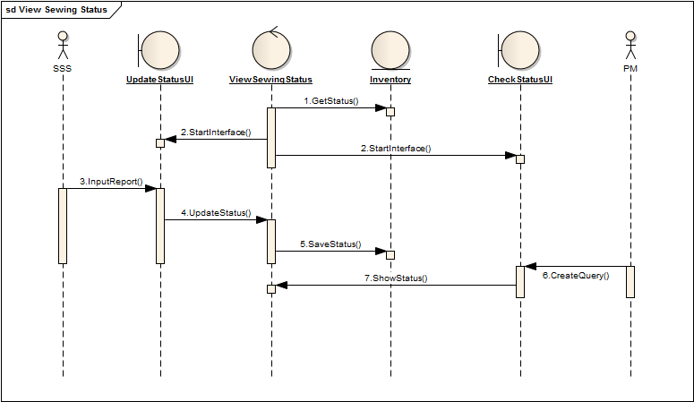

Sequence diagram for use case 3.3(view packing status)

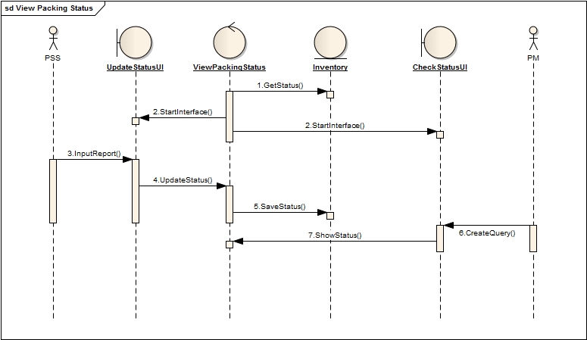

Sequence diagram for use case 3.4(view defection status)

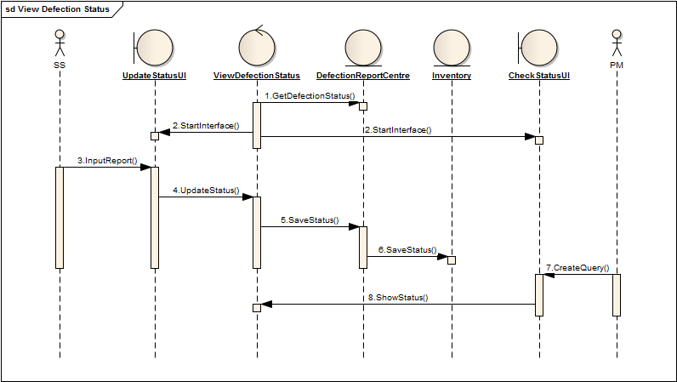

Sequence diagram for use case 3.5(update production status)

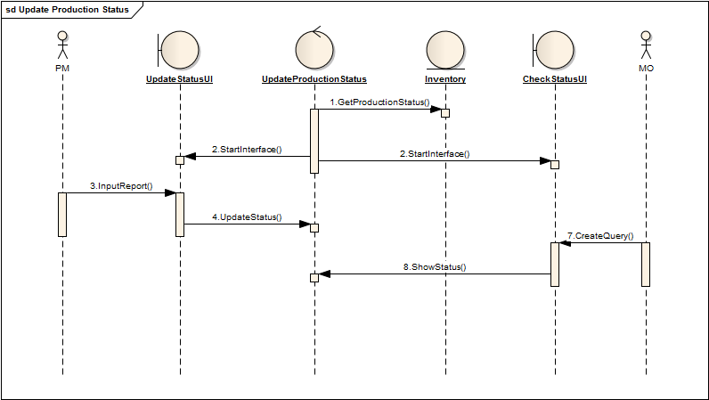

State chart diagram for entity “production inventory”

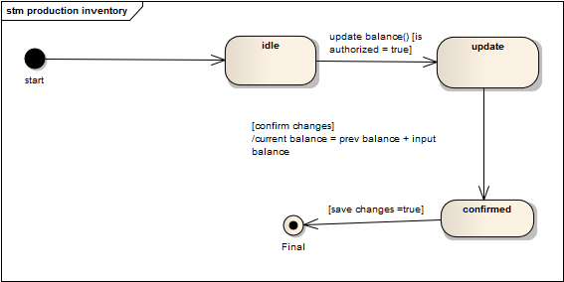

State chart diagram for entity “defection report center”



Activity diagram for “PRODUCTION STAGE TRACKING SUBSYSTEM”

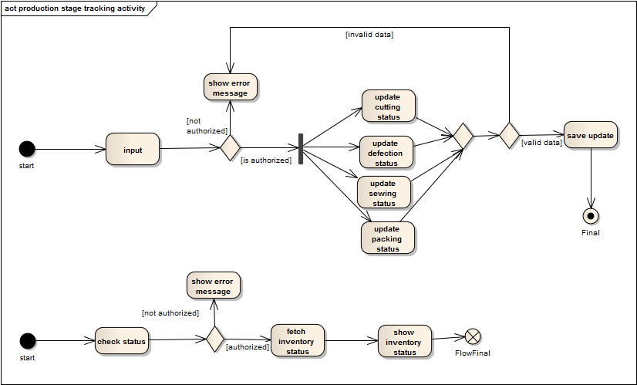

Subsystem 4: Delivery of products

Sequence diagram for use case 4.1(contact client)

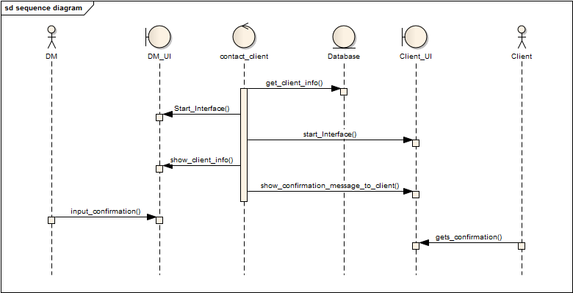

Sequence diagram for use case 4.2(Propose Shipment procedure)

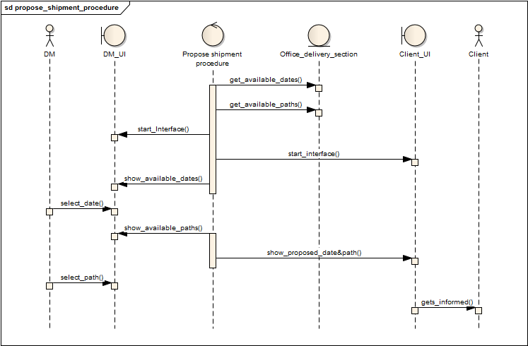

Sequence diagram for use case 4.3(Get response from client)

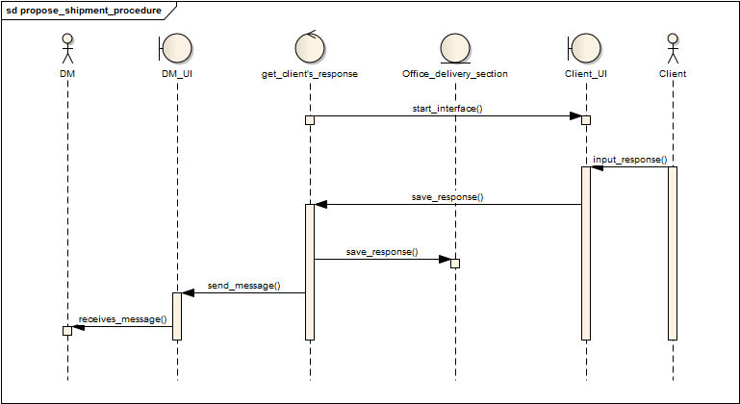

Sequence diagram for use case 4.4(Finalize Shipment)

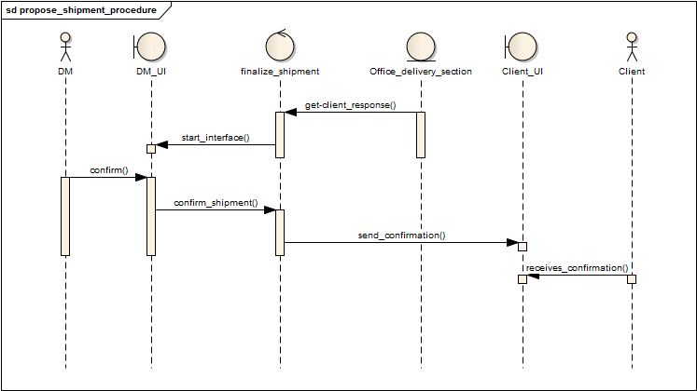

Sequence diagram for use case 4.5(Update Database)

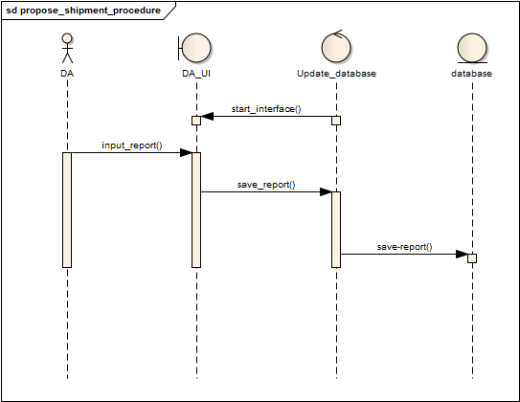

Sequence diagram for use case 4.6(Confirm Delivery)

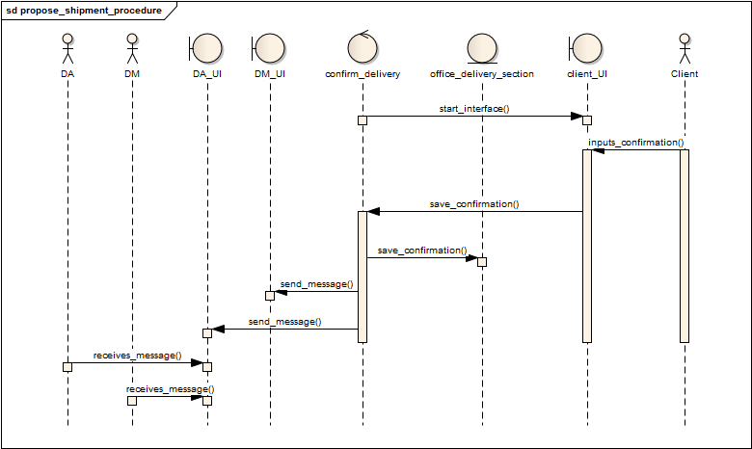

Sequence diagram for use case 4.7(Update Delivery Status)

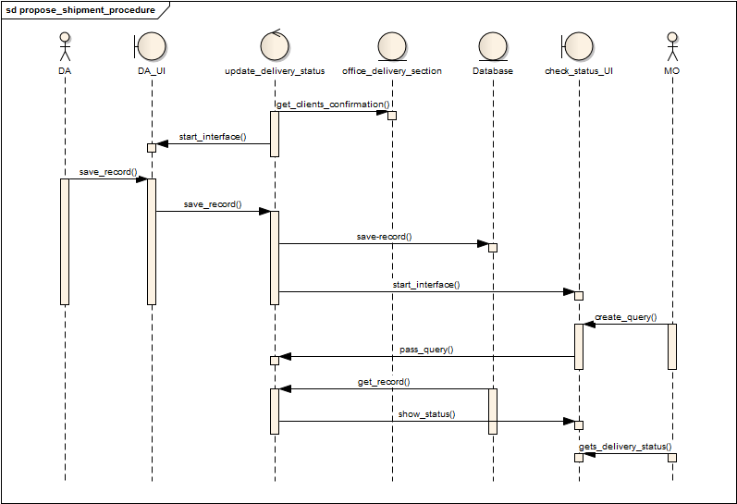

­­­

State-chart diagram for entity “Database”:

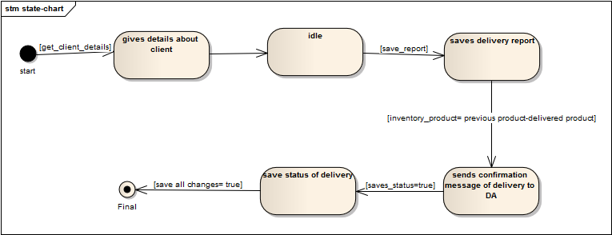

State-chart diagram for entity “Office-delivery-section”:

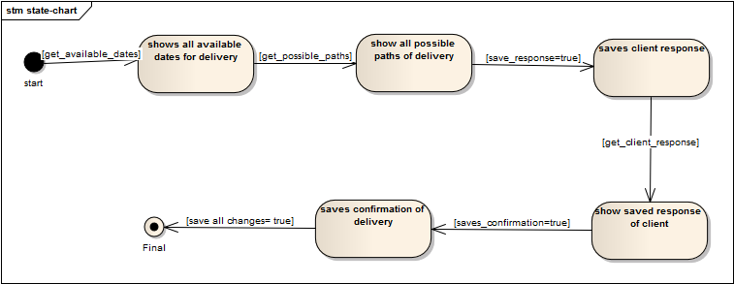

Activity diagram for “DELIVERY OF PRODUCTS”:

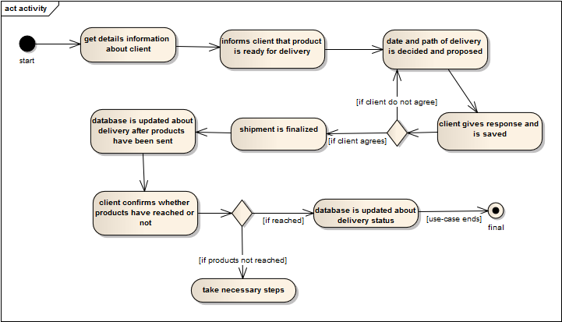

***********************************************END*************************************************